2. Description
This chapter will present and describe various aspects of the significance of the area of the serial nomination, which is situated in the Lower Galilee and along the northern shore of the Sea of Galilee. Beginning with a overview of the area’s physical geography, this chapter will provide a concise account of the overall history of the region and will survey the main local traditions related to the life and ministry of Jesus there. After summarizing the relevance of the area’s distinctive physical and cultural landscapes for understanding and appreciating the Gospel traditions, the chapter will conclude with a detailed description of each component of the nomination, highlighting the references made to each in the Gospels; each property’s main religious and spiritual significance; its history and architectural/archaeological resources; and the significance of its setting within a wider cultural landscape.

2.A. Setting the Scene: The Lower Galilee and the Sea of Galilee
According to the definition in paragraph 47 of the Operational Guidelines for the Implementation of the World Heritage Convention, a cultural landscape represents the "combined works of nature and of man" and is “illustrative of the evolution of human society and settlement over time, under the influence of the physical constraints and/or opportunities presented by their natural environment and of successive social, economic and cultural forces, both external and internal.” (UNESCO). In light of this definition, it is necessary to begin this chapter with a brief description of the complex interaction between the natural geological, environmental, and climatic characteristics of the region, the socio-economic-cultural developments that took place there in antiquity, and the sites and traditions of Jesus and the Apostles that are connected with them.
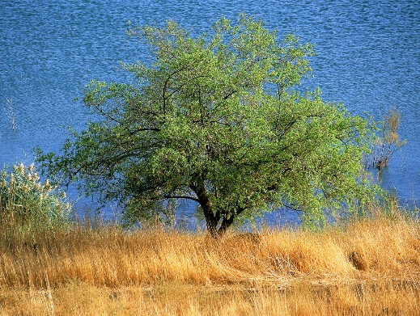
In its overall physical character, the general area in which the nomination is located is typified by mountainous topography interrupted by a chain of valleys running from west to east. In addition, fault lines extend throughout the region, creating alternating mountain blocks (horst) and downthrown blocks (graben) upon which lakes and river valleys were formed, most of which are short and straight. Despite the mountainous terrain, these lowland elements have provided convenient passages across the entire region from west to east and have served to encourage cultural contact and trade. Within these general characteristics of the entire region, the geographical foci of the serial nomination—the Lower Galilee and the Sea of Galilee (Fig. 1) —have distinctive environmental features, which will be described below.
Fig. 1. Ziziphus spina-christi tree (Christ's Thorn) typical to the area.
The Lower Galilee
The southern sector of the Galilee—known as the Lower Galilee—is itself divided into three distinct geological units: the western, central, and eastern. The stage upon which most of the story of Jesus and the Apostles was acted is the central and eastern Lower Galilee. As mentioned above, the area is characterized by ridges that extend in an east-west direction, rising to 500-600 meters above sea level, and separated by flat, fertile valleys. The northernmost ridges are composed of hard limestone
with fresh water springs at their bases. Because these limestone ridges lack arable soil on their summits, most of the ancient settlements in this area were built at the foot of the ridge slopes, near the springs and arable soil of the intervening valleys. However, in the south, in the area around Nazareth, the ridges are composed of chalk and arable soils can be found even on the ridge summits. Thus the settlements here are built higher on the ridge slopes and even on their summits.
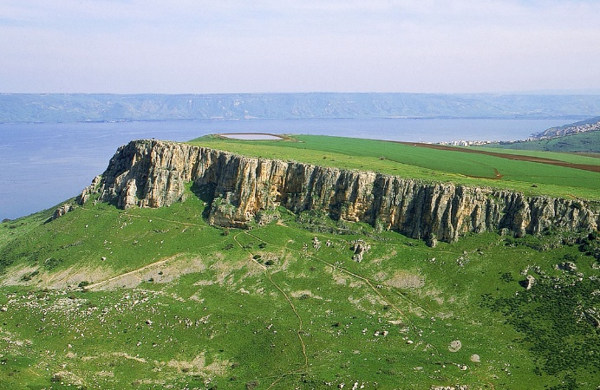
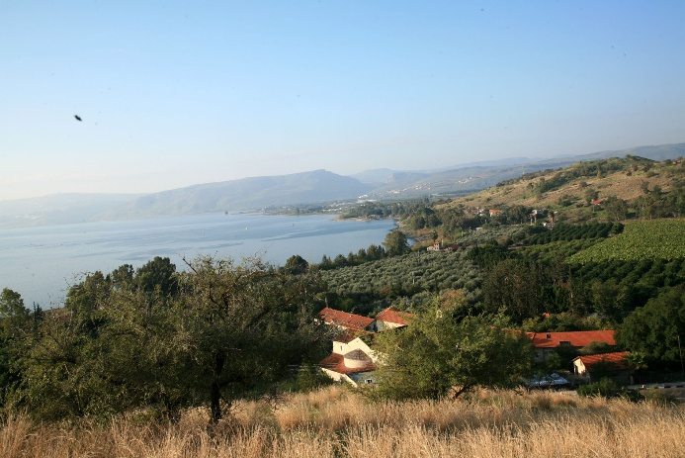
The eastern part of the Lower Galilee possesses different topographical characteristics from the central section. It is distinguished by fault lines that curve from west to east, whose eastern extremities face in a northwest-southeast direction. This geological structure has created a series of inclined plateaus with basalt, which over the millennia produced a thick layer of topsoil and created deep, precipitous river valleys (Fig. 2). The visual effect is of a series of almost flat plateaus rising from the southwest to the northeast and steep, almost vertical slopes that descending toward the river valleys and the Sea of Galilee (Fig. 3). As will be noted in section D of this chapter, the physical characteristics of both sub-regions are prominent in the gospel accounts and in the later traditions of pilgrimage throughout this region.
Fig. 3. The Arbel cliff.
Fig. 2. The valley of Tabgha looking west towards the Arbel cliff.
Climate and Rainfall also play a part in distinguishing the sub-regions of the Lower Galilee. The overall climate is Mediterranean, with a marked decrease in rainfall levels from west to east. In the west and center, the average annual rainfall of 500-600mm is sufficient for unirrigated farming; however, in the east, this is not possible due to the lower quantity and irregularity of the precipitation. Indeed the rugged topography, limited rainfall, and sparse vegetation of the easternmost part of the Lower Galilee have set it off from the gentle hills and slopes of the central sector around Nazareth, with its orchards (prominent among them olive groves), non-irrigated grain fields, and pastures for grazing.
Despite differences in topography, communication and transport throughout Lower Galilee was facilitated by a network of east-west roads that ran through the valleys or along the contact points between geological formations, without the necessity of crossing deep rivers or climbing steep slopes. Several important north-south roads also followed the natural topography. A main north-south route passed west of Tel Hannaton, reaching the Jezreel Valley at Shimron, while in the east another north-south road took advantage of the line of contact between the basalt and the soft limestone, running from Parod by way of Golani Junction and Hanat Tujar to the foot of Mount Tabor. These natural routes of communication offer a clearer understanding of the demographic movements and settlement developments within the area and its links to the nearby settlements along the northern shore of the Sea of Galilee—the other main geographical focus of the ministry of Jesus and the Apostles.
The Sea of Galilee
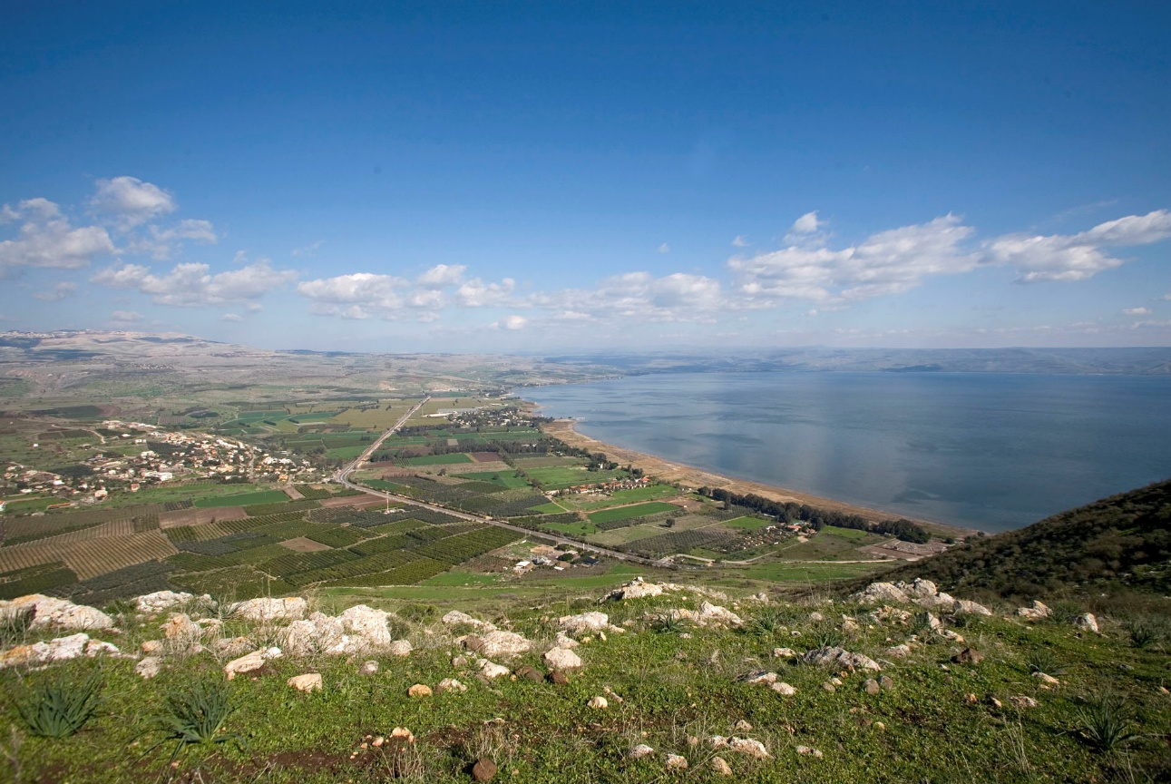
A main feature of the area connected with the ministry of Jesus and the Apostles is the Sea of Galilee, also known as the Lake Genasseret in the Gospels and as the Kinneret in biblical and modern Hebrew (Fig. 4). It is the northern remnant of the “Lisan Lake,” an ancient salt lake that extended from the northern end of the Kinneret to approximately 30 kilometers south of the present-day Dead Sea. The present Sea of Galilee extends about 12.5 miles (20 kilometers) from north to south and 7.5 miles (12 kilometers) from east to west at its widest point. Reaching a maximum depth of 144 feet (44 meters), it fills a west-to-east tectonic rift in the Jordan Valley that continues beyond the shores of the lake in the Ginnosar Valley on the western side and Habitikha Valley on the east.
Fig. 4. The north shore of the Sea of Galilee showing the Ginnosar Valley looking north.
The climate of the Sea of Galilee is characterized by high barometric pressure and relatively hot summertime temperatures, reaching an average maximum of 37° C. These temperatures stem from both its low elevation and the hot, dry westerly winds that sweep down over the steep hillsides, maintaining the warm temperatures until the late evening hours. In winter the average maximum daily temperature rarely falls below 18° C, preventing the formation of cold conditions and improving the agricultural qualities of its shoreline and the surrounding territory. The average rainfall on the northern shoreline is 475mm. Especially in the spring, toward the end of the rainy season, the weather is changeable and characterized by cloud bursts and intense storms as the valley heats up.
A major source of its water is the Jordan River which flows into it from the Hula Valley in the north, through a natural fracture in the Syro-African Rift created by ancient volcanic eruptions and lava flows. Cutting through the underlying basalt, the Jordan descends more than 850 feet (260 meters) over a distance of less than 9 miles (14 kilometers) and empties into the Sea of Galilee in a small delta. Other rivers also flow into the northern Kinneret through the Ginnosar and Habitikha Valleys. The Sea of Galilee also receives water from rain, from surface runoff from the surrounding slopes, and from springs, some of which are saline. The water level in the lake is c. 690 feet (c. 210 meters) below sea level; however, this average water level is subject to seasonal and year-to-year fluctuations that dramatically affect the position of the shoreline (Fig. 5).
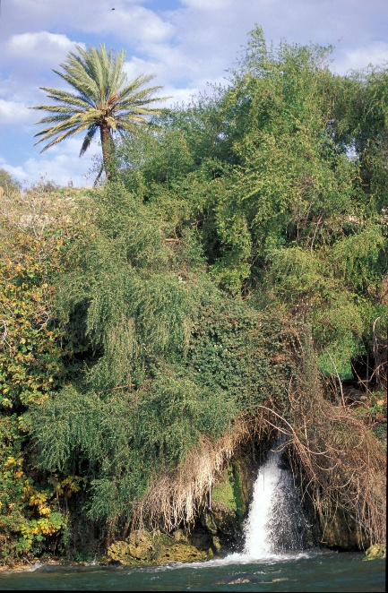
The soil in the valleys surrounding the Sea of Galilee is a dark heavy alluvium of limestone, chalk, and basal origin, rich in organic matter that is the result of swamps that covered the valleys in the past. These alluvial deposits provided rich soil for agriculture; permanent farming settlements existed in both the HaBitikha and Ginnosar valleys as well as in the drier, mountainous areas beyond the immediate environs of the lake.
Fig. 5. spring water near Ein Ayub flowing into the lake
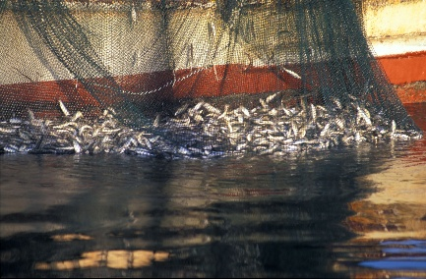
A distinctive supplement to the agricultural regime of the inhabitants of the shores of the Sea of Galilee was fishing which plays a conspicuous role in the imagery and activities of Jesus’ ministry as conveyed in the Gospels (Fig. 6). The hot springs of Tabgha, which flow forth in the northwestern corner of the Kinneret, also attract concentrations of fish at the point where the springs’ hot water meet the relatively cooler waters of the Kinneret, thereby creating a focal point for the activities of local fishermen. Three main types of fish were and still are sought by fishermen in the lake: sardines, barbels (so-called because of the barbs at the corners of their mouths), and amnun (also known as "St. Peter's Fish”) with a spiny , comb-like dorsal fin, that can be up to 1.5 feet (46cm) long and 3.3 lbs (1.5kg) in weight. As noted in Section 2D of this chapter, each type has clear associations with the Gospel accounts of the ministry of Jesus and the Apostles. Fishing has also been attested from archaeological finds in both the HaBitikha Valley (particularly at the site of ancient Bethsaida) and in the Ginnosar Valley (Migdal)—see Section 2E below. (Fig. 7)
Fig. 7. Fishermen on the lake
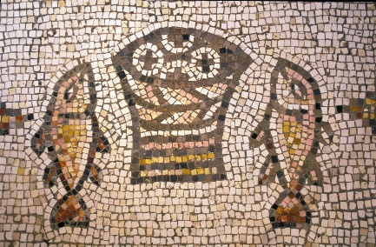
In some places settlements were established where the mountains of the eastern Lower Galilee descend steeply to the Sea of Galilee, leaving an extremely narrow strip of shoreline. The town of Capernaum, mentioned prominently in connection with Jesus’ ministry is located on one such section of the northwestern shore. Although its agricultural hinterland is tiny, the regional road adjacent to it provided its inhabitants alternative means of subsistence such as trade and tax collection, offering another example of the complex and diverse interaction of the region’s inhabitants with the constraints and opportunities of their natural environment.
Fig. 6. The mosaic from the Church of the Multiplication of the Loaves and Fish.

The Cultural Landscape of the Earliest Christian Traditions
As retold in the Gospels and enshrined in Christian tradition, Jesus spent his childhood in Nazareth and began his ministry in Kafr Cana. Both sites were small farming villages in the central Lower Galilee. Their shared cultural landscape, environmental setting, and social context offered a complex foundation for the later ministry and traditions that lay at the heart of Christianity. (Fig. 8) Leaving the region of his birth, Jesus made his way eastward to the settlements along the northern shore of the Sea of Galilee (or Lake Gennesaret as it is referred to in the New Testament), with its own distinctive geography, climate, and ways of life. The lakeside towns were to become the center of Jesus’ Galilean activity, so much so that Capernaum, and not Nazareth, is called his city (Mark 2:1, Matthew 9:1). It is from here he journeys afar—to Caesarea Philippi, Tyre and Sidon, and to the Land of the Gadarenes—but it is to here that he always returns. The settlements of Capernaum, Chorazin, Bethsaida, and Magdala no longer exist as living communities. The villages of Nazareth and Kfar Cana have become more substantial towns. Yet the surviving ecological setting, historical monuments, and archaeological excavations and the open areas around them still reflect and preserve elements of the unique interaction between man and his environment that gave rise to one of the great religious and cultural traditions of human history.
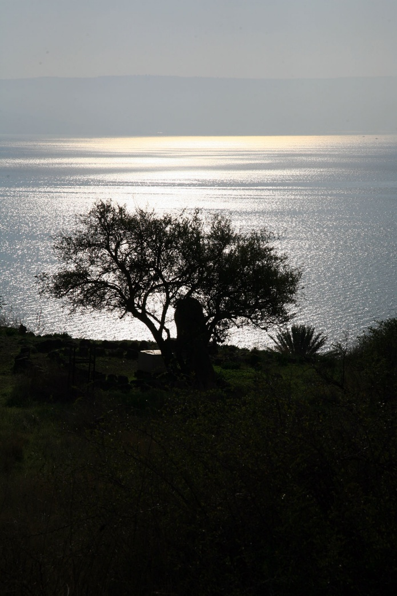

Fig. 8. A modern place for prayer and meditation set under a Ziziphus spina-christi tree (Christ's Thorn) on the slopes of the Mt. of Beatitude overlooking the Sea of Galilee.

2.B. A Concise History of the Galilee
A Geographical Definition of Galilee throughout history
Galilee is the northernmost region of ancient and modern Israel, stretching from the Jezreel valley in the south to southern Lebanon in the north, and from the Mediterranean Sea in the west to the Jordan valley in the east, encompassing an area of approximately 2,500 km². Its name, itself meaning 'district' or 'region', is a biblical term mentioned several times in the Old Testament referring to different areas within this region (e.g. Joshua 20,7; Kings I 9,11; Isaiah 8, 23). The physical landscape of Galilee is a very diverse one, characterized from the west to east by the coastal plain along the Mediterranean shore, the 'Shephela' hills to its east, a central mountain range (reaching a peak of 1200 m' at Mt. Meiron in upper northern Galilee) severed by several slip-fault east-west oriented valleys, and the deep Jordan rift-valley and Sea of Galilee basin reaching a low altitude of more than 200 m' below sea (ocean) level on its far eastern side. In Jewish historical and Talmudic sources from the Roman period and on a distinct division is made between the mountainous 'upper' (northern) Galilee, 'lower' (southern) Galilee which includes the hills of Nazareth and their surroundings, and the 'Valley' to its east with Tiberias as its main center (or possibly referring to the Gennesar valley of New Testament fame on the western shore of the Sea of Galilee). The latter two sub-regions of lower Galilee and the Sea of Galilee 'valley' are the areas relevant to our nomination theme – The Cradle of Christianity – for it is here that Jesus lived and ministered, here Christian faith was first nurtured and from here the propagation of Christianity was first set in motion.
Ancient Biblical Galilee: The Bronze and Iron Ages
Due to its relatively mild climate, abundant water sources and land-cultivation potential, Galilee has been settled since the oldest prehistoric times. During most parts of the Early Bronze (3000-2400 B.C.E.), Middle Bronze (2000-1550 B.C.E.) and Late Bronze (1550-1200 B.C.E.) periods, Galilee was characterized by a relatively advanced Canaanite culture, whose urban expression is manifested in the ancient cities/mounds located in the fertile valleys surrounding the region, e.g. Tel Acco on the Mediterranean, Tel Megiddo in the Jezreel valley, Tel Hazor in Upper Galilee (the largest of the biblical mounds within the borders of ancient Canaan), and Tel Beit Yerach and Tel Kinnrot (among others) in the Jordan valley in the east. During intermittent transitional periods between the urban phases of this 2,000 year long era, large parts of Galilee were inhabited by a semi-nomadic or nomadic populace. One of these latter periods, the Intermediate Bronze Age (ca. 2400-2000 B.C.E), had an especially long-lasting effect on the landscape of part of eastern Galilee – the Chorazin Plateau north of the Sea of Galilee – for it is during this period that hundreds of Dolmens and Tumuli (megalithic tombs) were erected which still dot the rocky basaltic countryside (see below, a description of the Chorazin surroundings). This unique phenomenon has created a 'biblical landscape' setting in the hinterland of this part of Galilee which hasn't changed much in the last 4,000 years, creating a realistic background of the actual scenery encountered also by Jesus and the population of eastern Galilee. These free-standing tombs are recorded in several ancient sources, among them the New Testament who probably refers to them in its references pertaining to outcasts who lived in 'tombs' (Mark 5, 1-5; Luke 8, 27; Matthew 8:28).
During most of the Iron Age (1200-733 B.C.E.) Galilee was mainly under Israelite control, although substantial Cannanite, Phoenician and Aramean influence is easily recognizable in almost all of the excavations of Iron Age sites. According to the Bible, after the conquest of Canaan by Joshua and the tribes of Israel (c.a. 1200 -1100 B.C.E.), the region was allotted to the northern tribes of Zebulun (western lower Galilee), Issachar (eastern lower Galilee), Asher (western upper Galilee) and Naphtali (eastern upper Galilee). In the 10th century B.C.E. it was part of the united kingdom of Israel under the reigns of David and Solomon (whose capital was Jerusalem); during the 9th century B.C.E. and until 733 B.C.E (save for some short periods of Aramaean rule) most of Galilee was part of the Northern kingdom of Israel whose capital was at Samaria. Excavations at sites like Megiddo, Hazor, Dan and Beithsada (ancient Biblical Geshur) have revealed that this last period was a cultural climax for the region as a whole; however, this biblical 'golden age' came to a sudden end with the violent conquest of Galilee by the Assyrians in 733 B.C.E., launching a long transition period of relative stagnation until the Hellenistic period beginning with the conquests of Alexander the Great in the late 4th century B.C.E.
The Hellenistic and Early Roman Periods - the Time of Jesus and his Disciples
During the late 4th, 3rd and 2nd centuries B.C.E. Galilee developed gradually under Hellenistic Ptolemaic and Seleucid rule, its material culture and pagan religion greatly influenced by its more affluent northern neighbor – Phoenicia. However, ca. 100 B.C.E., most of Galilee was conquered by the Hasmoneans, an event that triggered a mass influx of Judean Jews into all parts of the region, and especially into lower and upper eastern Galilee. By the time of the Roman conquest of Palestine in 63 B.C.E. (bringing an end to the independent Hasmonean kingdom), Galilee was probably mostly Jewish – a demographic situation that strengthened with time throughout the incoming Roman period (see below). Under the reign of Herod the Great (40 – 5 B.C.E.), a loyal patron of Greco-Roman culture, great building projects were undertaken in Judaea (e.g. at Caesara Maritima, Sebaste and Jerusalem) and at other sites outside of the country, albeit none were within Galilee proper, where Herod was especially despised. It was Herod's son Antipas (infamous in Christian tradition as the be-header of John the Baptist) - to whom Galilee was given after his father's death and who ruled the region until 39 C.E., spanning the full lifetime of Jesus - who advanced the region with urban development and administrative endeavors. Antipas carried out building projects in Sepphoris, the capital of Jewish Galilee until then (and in walking distance from Nazareth, Jesus's childhood home-town), while also founding the future capital of the region – Tiberias on the western shore of Galilee – in the year 20 C.E. (for that reason Tiberias, an embryo city during Jesus's ministry years, is hardly mentioned at all in the Gospels). Still, most of Galilee at the time of Jesus was rural in character, with a subsistence economy based on agriculture, fishing (in the Lake of Galilee), commercial and other local activities (e.g. toll-taxing at Capharnaum).
What were the cultural characteristics of the people of Galilee during this time period? By the late 1st century B.C.E. Jewish Galilee and Judea were sharing a common religious and cultural heritage, as is witnessed by common, widespread material features found in both areas. These include architectural (e.g. the usage of ritual baths), ceramic (e.g. oil lamps), stone-vessel (impervious to impurity), numismatic (Hasmonean coins), fauna (a lack of pig bones) and other material finds. Jewish Galilee in the time of Jesus was, for sure, not totally isolated from the larger Greco-Roman world (see, e.g., 1st century C.E. Roman-style monumental remains uncovered at Magdala), maintaining relations with the gentile cities of the Decapolis and of Phoenicia, with an additional gentile minority within its midst (e.g. the Roman Centurion at Capharnaum). But neither were its cultural traits fully incorporated into its own Jewish culture, showing conservative restraints even on the coins of Herod Antipas. These factors, coupled with literary data (attesting, for example, a strong Galilean regard for the Jerusalem temple), strengthen the view that the majority of the population within inner lower and upper Galilee in the time of Jesus was characteristically Jewish, descendants of Judean settlers in the wake of the Hasmonean Conquest, a paradigm greatly strengthened in recent years in wake of archaeological excavations and surveys conducted throughout the Galilee showing for a dramatic growth in population and development during the Late Hellenistic and Early Roman Periods. This, then, was the cultural landscape that confronted Jesus in his sojourns across Galilee, encompassing a conservative and mainly agrarian Jewish society enrooted in Judean tradition and custom.
The time of earliest Christianity in the aftermath of Jesus – the last years of the 2nd temple period in Jewish historical terms – was a time of relative turmoil, climaxing during the great Jewish revolt whose violent suppression began in Galilee in 67 C.E. Josephus Flavius, warrior turned-historian, provides us with full (although exaggerated) accounts of the events, and with many descriptions pertaining to the physical and cultural landscapes of Galilee (see, e.g., his vivid portrayals recorded in Wars 3.3.1-3, 3.10.7-8), and it is to his credit that we know of the great battles that took place at Magdala (one of the sites submitted here for nomination), Yodefat (in western Galilee), Gamla (in the Golan) and at other sites. However, the aftermath of the revolt did not bring about total destruction or abandonment; on the contrary, the settlements of Jewish Galilee on the whole survived and mostly continued into the Late Roman period (2nd-4th centuries C.E.) strengthened by an influx of Judeans fleeing Judea as a result of it's more intensive destruction in wake of both the 1st and 2nd revolts (the latter, under the leadership of Bar Kochva in 132-135 C.E., had few repercussions in Galilee). As for Christianity in these early years of its development, although the largest of the Early Judeo-Christian communities (the Minnim of Jewish sources) was in Jerusalem, pockets of Christians seemingly existed in several sites in Galilee, among them at Capharnaum, Nazareth and Tiberias.
Galilee during the Late Roman, Byzantine and Early Islamic Periods: Early Christian Diffusion
The Late Roman period (2nd-4th centuries C.E.) in Galilee is characterized both by Roman administrative rule and by a centrally-authorized Jewish autonomy whose main urban centers where located at Sepphoris and at Tiberias (the latter in the 3rd century becoming the spiritual center of Palestinian Jewry for the duration of the 1st millennium C.E.). A Roman imperial road network was laid out in all parts of the country; in Galilee the road best preserved (and which may still be partly tread on today) is the one crossing lower Galilee from Acco towards the Jordan valley rift via the Beit Netofa valley (passing north of Sepphoris) along a centuries-long-used ancient route, most certainly the same route that Jesus took on his way from Nazareth to the Sea of Galilee. From Jewish historical sources and from archaeological surveys it is clear that during the 2nd and 3rd centuries, especially in lower and upper-eastern Galilee, tens of Jewish villages dotted the countryside (although as yet without monumental synagogue-building); from Talmudical and Christian sources we may gather that small Judeo-Christian communities existed at several sites, such as Capharnaum, Sachnin (in lower central Galilee), Sepphoris, Nazareth and Tiberias. A recent, surprising, discovery of a mosaic-floored Christian house-chapel that existed in the 3rd century C.E. adjacent to the Roman Sixth Legion Ferrata army camp at Legio on the southern fringes of Galilee gives room for belief that other Christian communities, with communal-gathering places, existed in Galilee prior to the oncoming Byzantine era of official Christendom.
In 324 C.E. Emperor Constantine declared Christianity to be the official religion of the Roman empire, heralding the Byzantine era and turning Palestine into the Christian 'Holy Land'. In the wake of Helena the emperor-mother, Christian pilgrimage to traditional and newly-identified holy sites became common during the 4th century and intensified greatly during the 5th and 6th centuries, accompanied by the building of memorial shrines, churches and monasteries at the sites themselves and in their environs. In Galilee, shrines (usually altars) and early chapels (some of which have been uncovered in excavations) are recorded at Capernaum, Tabgha, Nazareth and several other sites by 4th century pilgrims, the most important of whom is Egeria who visited Galilee in the latter part of the century. In the 5th and 6th centuries tens of churches and monasteries were added to those sites and to others commemorating events relating to the life of Jesus and to his ministry (e.g. at Tiberias, Cursi, Cana, Mt Tabor etc.), catering to hundreds of pilgrims whose itineraries by the 6th century were molded into constant and definitive geographical routes (see, e.g., Theodosius's 6th century description of pilgrimage routes; Y. Ashkenazi, below). Thus, it is the Byzantine period that should be considered the formative stage in the shaping of the Christian 'Holy Land' tradition. It is during this period that Galilee also undergoes a deep change in settlement pattern and demography: Although parts of lower Galilee and especially upper eastern Galilee remain Jewish enclaves (and witness a surprising pinnacle of monumental synagogue construction, despite a general decrease in settlement density), western Galilee (especially its upper northern area, west of Mt. Meron) flourished with tens of Christian villages and Churches. Large Christian communities existed also in the cities of Tiberias and Sepphoris, alongside the Jewish population; it is quite feasible that even in countryside villages dual Christian and Jewish communities lived side by side (as at Capernaum).
The 7th century C.E., a time of political unrest and upheaval, brought to Galilee 'new winds' from the south-east: the Moslem conquest, bringing a new political and ethnic/religious entity to the foreground of events for centuries to come, while also setting in motion a general decrease in settlement density especially in the peripheral areas of the region. However, recent research has shown that both Jewish and Christian communities continued to exist and even thrive at some sites (as in Tiberias) during the Early Islamic period (7th-11th centuries C.E.); several sacred Christian sites were fostered with chapel-construction (e.g., at Magdala), and Christian pilgrims and travelers continue - although less frequently - to visit the holy sites of Galilee.
Galilee in the 2nd millennium C.E.: the Crusader, Mamluk and Ottoman periods
The Crusader conquest of 1099 C.E. and the establishment of the Latin Kingdom of Jerusalem brought to Palestine in general and the Galilee in particular a period of Christian renaissance, including a more than full resurgence of pilgrimage and the re-sanctification and refurbishing of holy sites such as Mt. Tabor, Nazareth, Cana and Tabgha . Tiberias, the capital of the principality of Galilee in 12th century, was built anew north of the old Roman city, with newly sanctified sites (as the Church of St. Peter). Newly consecrated sites were established in other parts of Galilee as well, as at Sepphoris and at Safed, as part of the regeneration of the 'Sacred Geography' of the Holy Land. To this sacral activity we should add, of course, the monumental construction of castles and citadels whose remains still dominate large parts of the landscape (as at Belvoir, Safed, Monfort, Vadum Yaakub, Hunin). However, this revival was short-lived, for on July 4 1187, in the battle of the Horns of Hattin in lower Galilee, Saladin succeeded in crushing the Crusader army, eventually bringing on the downfall of the Crusader kingdom. Although additional Crusades and European support enabled temporary Crusader rule over large parts of the land – including Galilee - during the 13th century (when cosmopolitan Acre became the largest city in the land, with a population of some 40,000, as big as London), that defeat may still be seen as one of the important turning points in the history of the Levant; a second important and critical event that occurred on the fringes of Galilee in 1260 C.E. in the Jezreel valley was the defeat of the Mongols at the hands of the Mamluk Sultan Beibars, who was also to succeed in finally thrusting out the Crusaders from their last strongholds in Galilee in the 1260's. Acre itself fell finally in 1291, bringing on the ultimate demise of the Crusader kingdom and Frankish society that thrived for almost 200 years in the Holy Land, a blow to Christian aspiration from which the Christian world would never really recover.
The following centuries, under Mamluk (14th-15th centuries) and Ottoman rule (16th-19th centuries), were periods of relative stagnation, whereby Palestine played a minor role in the Geopolitics of the Levant. Christian and Jewish minorities continued to exist among the Moslem majority at several sites in Galilee (Safed was then the largest city in the region, becoming a spiritual center for the Jews world-wide in the 16th century), but only in the late 19th century was there a resurgence of European-Christian interest and activity in Galilee, when Catholic Italian-Franciscan and German-Benedictine societies began purchasing patches of land encompassing the traditional Holy Christian sites in the Nazareth and Sea of Galilee vicinities. These sites, which flourish today in the northern part of Israel, form the hub of Christian pilgrimage revival to an extent never seen before; it is this 'Cradle of Christianity' that hereby will be described in full and submitted for nomination as a World-Heritage site.

2C. Traditions Related to the Early Life and Galilean Ministry of Jesus
The events of the early life and ministry of Jesus in the Galilee are a rich source of narrative, religious symbolism, ethical parables, and visual imagery that have been revered within the Christian tradition as it has evolved over the centuries. This section will describe the various textual and non-textual sources that memorialize and commemorate the Galilean ministry of Jesus—and which bear unique testimony to the ancient origins and continuing vitality of this universal religious heritage.
Overview of the Gospel Accounts
Although the New Testament Gospels of Matthew and Luke firmly identify the birthplace of Jesus as the Judean town of Bethlehem, all of the canonical Gospels describe his roots in the Galilee as profound and deep. Except for the events surrounding his Nativity and the relatively brief episodes of his family’s Flight into Egypt (Matthew 2:13-23), his boyhood visit to the Temple (Luke 2:41-52 ), his baptism in the Jordan, his later journey to Tyre and Sidon, and of course his Passion, Crucifixion, and Resurrection in Jerusalem, the vast majority of the reported events of his life occurred in the relatively small area extending from Nazareth in the west to the northern shore of the Sea of Galilee (See Fig. 9).
Although the individual Gospels differ in details and the order of events, the main outlines of Jesus’ early life and ministry are clear. After spending his boyhood and early adulthood in the town of Nazareth (see below Section 2E, 1), perhaps following the trade of a carpenter (as suggested by Mark 6:3 and Matthew 13:55), he underwent a spiritual awakening and received a messianic calling to announce to the people of Galilee the imminent advent of the Kingdom of God.
Embarking on a public ministry in the towns of the central Lower Galilee and along the northern shore of the Sea of Galilee, he met with people from the margins of the Galilean society: fishermen, farmers, tax collectors, sick and poor men and women amongst whom he performed miracles and delivered his powerful sermons and teachings. After leaving Nazareth, and receiving his Divine mission in the Jordan Valley, he returned to Galilee, attending the wedding feast at Cana (see below Section 2E, 2), where he performed his first miracle (John 2:1-12). This was also, according to John 4:46-54) the site of a later healing. Nearby, at the village of Nain, Jesus raised a young man from the dead, an act that spread news of his mission among the people of the surrounding territory (Luke 7:11-17). He subsequently established his base in the lakeside town of Capernaum (see below Section 2E, 7), where he performed many healings (Matthew 8:5; Mark 1:21–28; 2:1–12; Luke 7:1–10; John 4:46–54) and offered regular teachings in the local synagogue (Luke 4:31–38; John 6:22–59). At Capernaum, Jesus gained the adherence of his first disciples, Peter, Andrew, James, John, Matthew (Matthew 4:18, 21; 9:9; Mark 1:16) with whom he traveled and sailed on the waters of the Sea of Galilee. Another of his early followers, Mary Magdalene (Luke 2:2;), likely came from the nearby western lakeside town of Magdala (see below Section 2E, 4).
Extending his mission to other towns along the northern shore of the Sea of Galilee and farther inland, Jesus preached and performed miracles at Bethsaida and Chorazin (Matthew 11:20-24, Luke 10:12-16; see below, Section 2E, 8). He fed the multitude from a few loaves and fishes (Matthew 14:13-21; Mark 6:30-44; Luke 9:10-17; John 6:1-15), and withdrew to a place called “the Mount of Beatitudes,” where he preached the central tenets of his new moral and ethical message in the Sermon on the Mount (Matthew 5-7).
After journeys and miracles among the people on the eastern shore of the Sea of Galilee and, later, in the Phoenician towns of Tyre and Sidon and at Caesarea Philippi, Jesus returns to his Galilean homeland, to be metaphysically transfigured before his disciples Peter, James, and John on a “high mountain,” revealing to them his messianic destiny (Matthew 17:1-9; Mark 9:1-8; Luke 9:28-36). His Galilean ministry was approaching its conclusion as he announced his intention to travel southward to Jerusalem to celebrate the Passover Feast (Matthew 19ff; Mark 10ff; Luke 9:51ff; John 11:55ff.) Yet even after the awesome events of Jesus’ Passion, Crucifixion, and Resurrection, Galilee was not forgotten. The message of the Sermon on the Mount, the parables, and the miracles remained at the core of the faith proclaimed by Jesus. Indeed, according to the Gospel of Matthew, when Mary Magdalene and the other women came to the empty tomb of Jesus and learned of his resurrection, they were solemnly instructed by an angel: “He is going before you into Galilee; there you will see Him” (28:7). Jesus himself soon appeared to them with the same message: "Do not be afraid; go and tell my brethren to go to Galilee, and there they will see me." (28:10) It was there, in the hills, in the lakeside towns, and on the sea itself that his message lived on.
Apochryphal Gospels and Other Traditions
The Galilean narratives of the canonical Gospels were not the only source of Christian traditions about Jesus’ early life and early ministry. With the spread of the Christian faith in the first centuries of the Common Era, a vivid genre of religious literature developed, further elaborating the traditions relating to Jesus’ infancy and his childhood in Nazareth. Prominent among the works of this type is the Infancy Gospel of Thomas that expands on the childhood of Jesus, adding vivid anecdotes and details about his life among the people of Galilee.
Early Christianity, the Rise of Pilgrimage, and the Shrines of Galilee
Although the leadership of the faith begun by Jesus remained in Jerusalem after his crucifixion, some scholars suggest that a branch of the Jerusalem Judeo-Christian sect went back to the Galilee and remained there until the fourth or even the fifth century. There are some indications that in some places in the Galilee, such as Capernaum, there were communities of Judeo-Christians between the first and third century C.E.
Yet there is no doubt that the main centers of the crystallizing Christian faith were established elsewhere—at first in Jerusalem, Caesarea, and Damascus—and later in the cities of Asia Minor, Greece, and Rome itself, through the efforts of the Apostle Paul. The Acts of the Apostles– a book that serves as a main source for the beginnings of Christianity – tells of a small group of disciples in Jerusalem that maintained a passionate belief in the messiahship of Jesus and was combined of 'Hebrews' and 'Hellenes'. This small group grew rapidly as did the tension between the two parties within the community, eventually leading to a partition between them. While the community in Jerusalem remained mostly Hebrew, the Hellenes left Judea and developed new communities of gentile believers in Jesus Christ (Christos, “the anointed one) in the urban centers of other parts of the Roman Empire. Not bound to a Jewish identity, these believers in Christ became the followers of the new religion of Christianity.
After the destruction of Jerusalem during the Great Revolt (70 C.E.), the small Judeo-Christian community settled on Mount Zion, but with the end of the Bar Kochba Revolt in 135 C.E. the Hebrew Christian community there came to an end. Jerusalem became Aelia Capitolina, the Jews were expelled from the city, and the new Christian community that developed there from the 2nd century onward was of gentile origin.
By the third century, the coastal city of Caesarea had become the most important Christian center in Palestine and it was there that the intense study of the gospels and other early Christian literature led to the “rediscovery” of some of the most important sites of Jesus’s ministry. Eusebius, Bishop of Cæsarea in the early 4th century, collected geographical and historical information related the holy places in his Onomasticon (written c. 330) in order to support the understanding of the scriptures, and St. Jerome (Hieronymus) visited the sites in order to study them (Limor 1998).
Soon visits to the places sanctified by the life and works of Jesus and the apostles became more than a scholarly endeavor; they became an officially recognized part of Christian ritual (Wilken 1992). The earliest recorded pilgrimage goes back to the third century with the mention of Bishop Alexander, but with the conversion of the Emperor Constantine and the visit of the Empress Helena to Jerusalem, pilgrimages to the Holy Land became much more frequent. The identification of the holy places was based on local traditions and the testimony of local clerics who guided the pilgrims from abroad, reading texts from the scriptures and praying at the sites. During the early Byzantine period the pattern of the pilgrimage itineraries was set, and the map of the holy places and the preservation of the holy traditions by the construction of a commemorative structure or by the observance of religious rituals was already established (Limor 1998).
Jerusalem was the most important pilgrim destination. During the journey of Helena to the east she had reportedly identified the place in Jerusalem where the True Cross was buried and she commissioned the construction of an impressive a shrine at the place of Crucifixion – the Golgotha. In addition, her son Constantine built an impressive Basilica over the tomb where, according to tradition, Christ was buried and resurrected. Together with the other shrines commemorating Jesus’ Nativity at Bethlehem and his Ascension on the summit of the Mount of Olives, Jerusalem’s holy places drew the pious attention of growing numbers of Christian noblemen, high clerics and pilgrims who began arriving from all over the Roman world.
Galilee, as the boyhood home of Jesus and the scene of his public ministry, was soon to become another major destination for Christian pilgrimage. From the 4th century onward, pilgrims’ itineraries, most of them written in Latin, describe the Galilee and its holy places. The earliest is that of Egeria, a nun from Iberia or Gaul who visited Palestine between the years 381-384 C.E. According to her description, Egeria visited Tabgha, Capernaum, and the Mt. of Beatitudes and saw Nein and Nazareth, Tiberias and Mt. Tabor.
Around the same time, in 385 C.E., Paula, a disciple of St. Jerome who resided in Bethlehem, came on a pilgrimage to the holy places in Palestine. Jerome describes her visit to the holy places in one of his letters, written in 405:
"Then she passed quickly through Nazareth the nursery of the Lord; Cana and Capernaum familiar with the signs wrought by Him; the lake of Tiberias sanctified by His voyages upon it; the wilderness where countless Gentiles were satisfied with a few loaves while the twelve baskets of the tribes of Israel were filled with the fragments left by them that had eaten. She made the ascent of mount Tabor whereon the Lord was transfigured."
The next pilgrims’ itineraries of visits to the Galilee that have survived are from the 6th century. De Situ Terrae Sanctae, written by Theodosius mentions Nazareth, Mt. Tabor, Cana, Magdala, Tabgha, Capernaum and Bethsaida. Since the places appear in a geographical order, the work may have served as an early "tourist guidebook".
"From Tiberias it is two miles to Magdala, where my Lady Mary was born. From Magdala it is two miles to Seven Springs, where my Lord Christ baptized the apostles, and where he satisfied the people with five loaves and two fishes. From Seven springs it is two miles to Capernaum. From Capernaum it is six miles to Bethsaida, where the apostles Peter, Andrew, Philip, and the sons of Zebedee were born."
The next itinerary is by the traveler from Piacenza in Italy who visited the holy land by the end of the 6th century (Mistakenly he was called Antoninus, but his true identity is unknown). His descriptions are more lively then his predecessors, and it seams that the things he saw, the people he met, and the stories he has been told in the holy places, personally thrilled him. Such was the Jars of wine that he saw in the church at Cana. Here is his description of Nazareth:
"We traveled to the city of Nazareth, where many miracles take place. In the Synagogue there is kept the book in which the Lord wrote his ABC. And in this synagogue there is the bench on which he sat with the other children…The house of Saint Mary is now a Basilica, and her clothes are the cause of frequent miracles".
Thus, by the 6th century CE the tradition of Christian pilgrimage to the holy sites of Galilee was well established. Despite the end of Byzantine rule in Palestine in the early 7th century, this ancient tradition would continue—dramatically increasing during the Crusader period with a new wave of commemoration and construction of pilgrimage shrines—and continuing up to the present day.

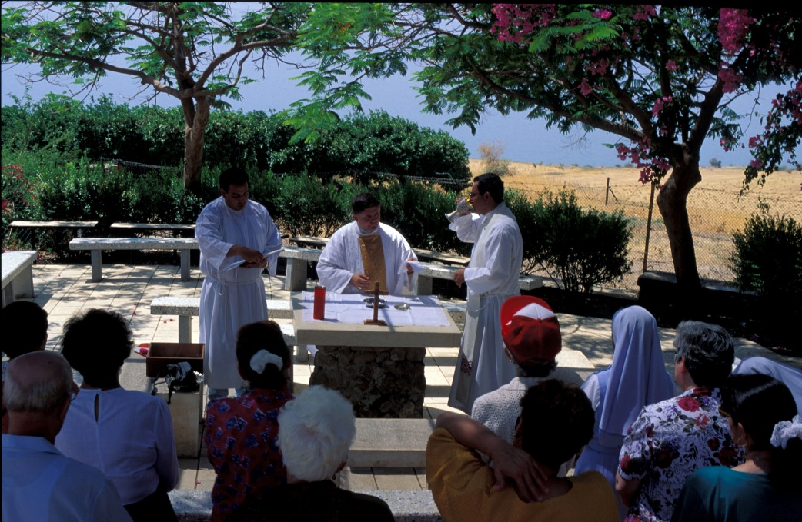
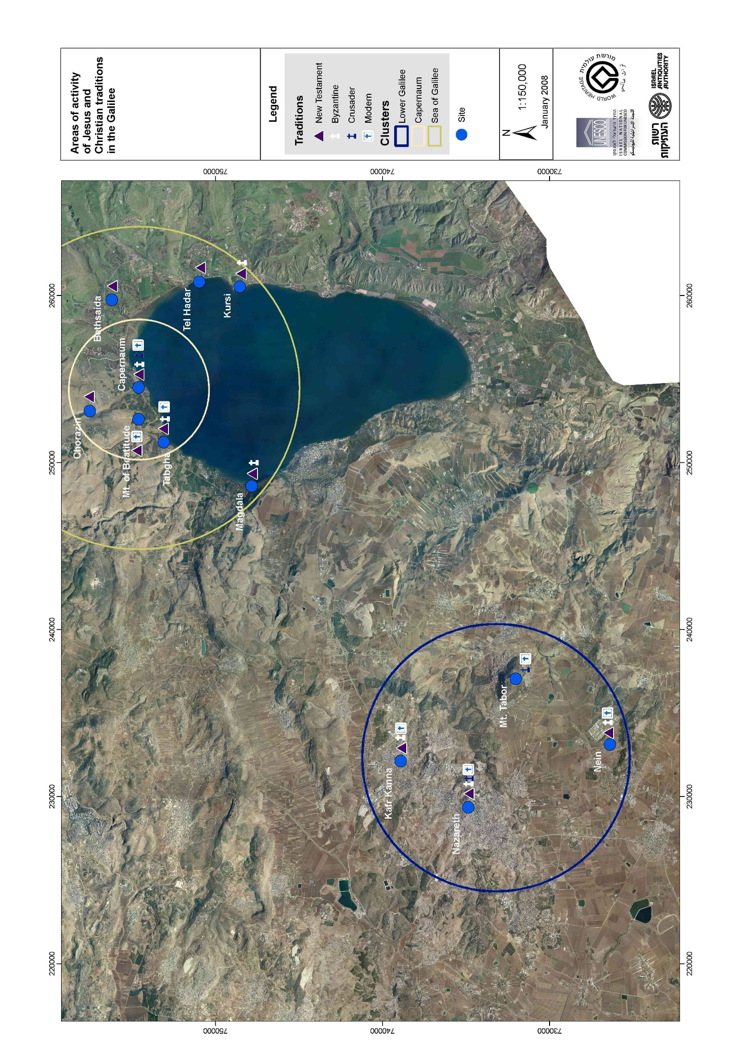
Fig. 9. Areas of activity of Jesus and Christian traditions in the Galilee
Fig. 70. present day pilgrims on the shores of the Sea of Galilee (the Church of the primacy of St. Peter at Tabgha)

2D. The Galilean landscape of the Gospels
The landscape of the New Testament: The Fifth Gospel
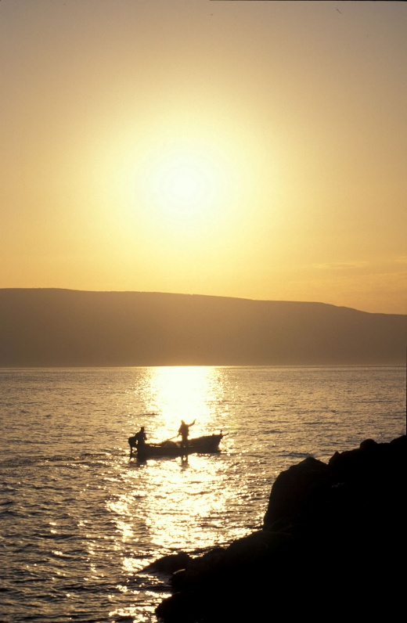
"All this history, which, at a distance, seems floating in the clouds of an unreal world, thus assumed a body, a solidity which astonished me. The striking accord of the texts and the places, the wonderful harmony of the Evangelical ideal with the landscape which served as its setting, were to me as a revelation. I had before my eyes a fifth Gospel, torn, but still legible, and thenceforth, through the narratives of Matthew and Mark, instead of an abstract being, which one would say had never existed, I saw a wonderful human form live and move".
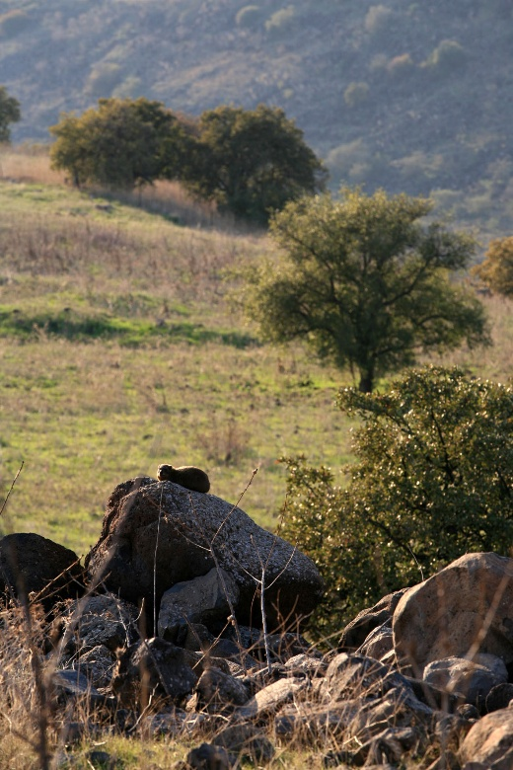
These words, written by Ernest Renan in 1863 after a visit to the Galilee, clearly express the importance of the landscape where the events described in the gospels occurred. As we know, the New testament contains four canonical gospels—Matthew, Mark, Luke, and John—yet in the eyes of Renan and of countless pilgrims and visitors to the region over the last 1700 years, the Galilee’s landscape is nothing less than a fifth gospel that materializes and sharpens ones understanding of the occurrences described in the texts; the events recounted in the scriptures, by means of the fifth gospel “floating in the clouds of an unreal world”, take on a clear and defined form (Figs. 10, 11).
Fig. 10 General view of fishermen on the Sea of Galilee
It is true that this perception is most profound for devout Christian visitors; however, it is not limited solely to them. The images of Jesus’s ministry, filled with rich imagery and memorable details about water turned into wine, miraculous healings, fishermen’s nets bulging with their catches, and the stilling of troubled waters are part of a wider cultural inheritance. It should be noted that in Renan’s book, from which the text above is quoted, does depict Jesus as a divine supernatural entity; rather he is seen as a man who is “at the highest summit of human greatness” and he is like “the highest of these pillars which show to man whence he comes, and whither he ought to tend”. In other words, the importance of the fifth Gospel is not just its relevance to a particular doctrine, but its significance as a cultural and moral inheritance for people of many faiths.
Fig 11. Chorazim Plateau with wild life (Procavia capensis) and typical flora.
flora.

The expression of the landscape in the Gospels
The landscapes of the Galilee play an important role in the message of the scriptures, in the same way that the text has been read into the landscape for centuries. It is this unique reflexive relationship between the gospels and the Galilee’s climate, geology, and flora and fauna that underlie the region’s deeper significance to the visitor. Examples of the connection between the earthly and spiritual realities expressed in the gospels are many; they give voice to the perceptions of the Galilean farmers, fishermen, and the other toilers on sea and soil. Indeed, it is only in visiting the sites and landscapes of the Galilee that one can appreciate the rich natural imagery of Jesus’s sayings, metaphors, and parables (Fig. 12).
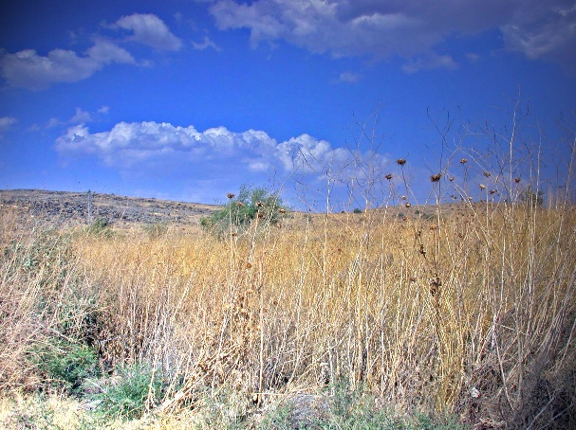
For example, Jesus frequently left the villages and towns to preach in the natural areas that lay between them and the gospel descriptions of these areas are rich with the imagery of the fauna and flora of the wilderness frontier. There were few trees or bountiful fields and many rocks and wild plants. A short trip outside Capernaum brought Jesus and his disciples to an “isolated mountain” where he gave his famous Sermon on the Mount in which he skillfully used natural and agricultural imagery familiar to the people of 1st century Galilee:
Fig 12. Characteristic landscape of few trees and thorns on the Chorazim Plateau

“Consider the lilies of the field, how they grow; they neither toil nor spin” (Matthew 6:28).
“Look at the birds of the air: they neither sow nor reap nor gather into barns, and yet your heavenly father feeds them…” (Matthew 6:26-27).
“You will know them (the false prophets) by their fruits. Are grapes gathered from thorns, or figs from thistles? So every sound tree bears good fruit, but the bad tree bears evil fruit. A sound tree cannot bear evil fruit, nor can a bad tree bear good fruit. Every tree that does not bear good fruit is cut down and thrown into the fire” (Matthew 7:16-19).
“Foxes have holes and birds of the air have nests; but the Son of man has nowhere to lay his head” (Matthew 8:20).
On another occasion, Jesus describes a distinctive characteristic of Galilean geography—the meeting point between the fertile soil and the rocks, the sun-scorched region and the well-watered region—in a famous parable:
“A sower went out to sow, and as he sowed, some seeds fell along the path, and the birds came and devoured them. Other seeds fell on rocky ground, where they had not much soil, and immediately they sprang up, since they had no depth of soil, but when the sun rose they were scorched; and since they had no root they withered away. Other seeds fell upon thorns, and the thorns grew up and choked them. Other seeds fell on good soil and brought forth grain…” (Matthew 13:4-8).
The Sea of Galilee is perhaps the most dramatic physical feature associated with the ministry of Jesus, who drew his disciples from among the lake’s fishermen, promising to make them “fishers of men” (Mark 1:17). Along the shores of the lake one can still detect the remains of anchorages from antiquity and walk the now silent streets of the fishing ports of Capernaum and Magdala. Yet it is their uncanny knowledge of the weather and the conditions on the sea that the gospels reveal a direct and earthly reality (Fig.13).
For the conditions on Sea of Galilee—especially at the end of the rainy season in the springtime—is characterised by cloud bursts and intense storms that are unusual for such a relatively small lake. In the winter there is no stable wind pattern, a fact expressed clearly in the gospel narratives:
“When you see a cloud rising in the west, you say at once, ‘A shower is coming’; and so it happens. And when you see the south wind blowing, you say, ‘there will be scorching heat’; and it happens” (Luke 12:54).
Jesus’s ability to control the uncontrollable was therefore expressed in the language of water and gale: “Then he rose and rebuked the winds and the sea; and there was a great calm” (Matthew 8:26).

The Galilee in World Literature and Art
These images of nature expressed in the gospels have also found expression through the centuries in enduring works of art. Many were those unable to make the physical pilgrimage to Galilee, yet were still inspired by the scriptural imagery. This, too, is a part of the Galilee’s universal significance—and a basis for reflection and creativity. For while the “Stations of the Cross” in Jerusalem could be installed in a literal way on the walls of churches throughout Christendom and the scene of the Nativity at Bethlehem could be fashioned with familiar figures for Christmas celebrations, the fields and hills and lakeshore of the Galilee where Jesus preached and healed and wandered remained more challenging artistic motifs.
Yet the challenge was taken up again and again over the centuries. Whether it was Giotto’s fresco of the “Wedding at Cana” (c. 1303-1305) or Hieronymous Bosch’s quite different depiction of the same scriptural event in oils (c. 1485); whether the subject was Jesus stilling the waters in Tintoretto’s “Christ at the Sea of Galilee” (1575) or Rembrandt’s “Storm on the Sea of Galilee” (1633), the images and events of the ministry of Jesus became part of the wider artistic heritage of the world.
Even into modern times the Galilee retained its power for artistic inspiration. Richard Strauss’s opera Salome (1905), based on the play by Oscar Wilde takes place on a balcony overlooking the waters of the Sea of Galilee. And Wilde himself had earlier expressed the theme of the turbulent waters in his sonnet E Tenebris (1881):

Come down, O Christ, and help me! reach Thy hand,
For I am drowning in a stormier sea
Than Simon on Thy lake of Galilee:

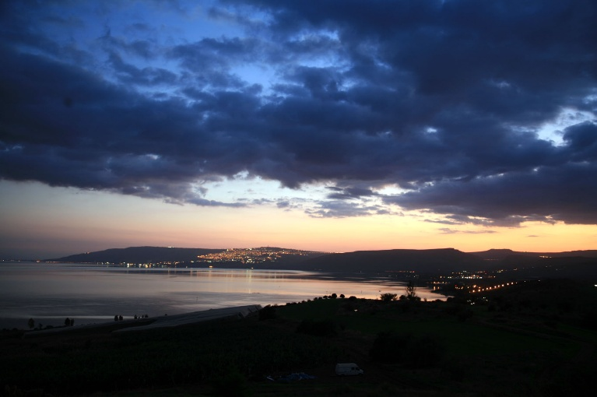
The names, the images, and the symbols—no less than the ancient shrines and the Galilee’s natural landscape—are a part of world heritage.

2.E. Description of the property and history and development of each of the component parts
Fig 13. Dramatic skies
over the Sea of Galilee

.
flora.

- Nazareth
  - The Basilica of Annunciation
  - The Church of St. Joseph
  - The Church of St. Gabriel
  - Mary's Well
- Kafr Kanna
- Magdala
- Tabgha
  - The Church of the Multiplication of the loaves and fishes
  - The Church of the Primacy of St. Peter (Mensa Christi)
- The Mount of Beatitude
- Capernaum
  - The Franciscan compound
  - The Greek Orthodox compound
- Chorazin
- Mt.Tabor

These include the Zebulon, Jezreel, Harod and Bet Shean valleys.
The level of this Pleistocene formation, at c. 180m below sea level, was 200m higher than that of the present Dead Sea. Its area is characterized by the deposition of soft friable rock known as Lisan marl.
In the Ginnosar Valley, Nahal Amud descends through steep ravines from the mountains of Safed, Nahal Tsalmon and Nahal Arbel, which extends from the Lower Galilee. To the East, the Habitikha Valley serves to drain many of the Golan’s rivers that reach it through a number of parallel river valleys.
However, the use of ossuaries in burial tombs, a prevalent Judean practice sometimes mentioned as a trait common in Galilee at the time of Jesus, seemingly began in Galilee slightly later, at the end of the first or during the 2nd century C.E..
In the 12th century, Peter the Deacon, a librarian in the monastery of Monte Casino, wrote a book in which he used an ancient manuscript of the itinerary of Egeria. The parts of Egeria itinerary where she described the holy places in Galilee are preserved in Peter the Deacon's Book.
Jerome, Letters, 108: 13 (trans. P. Schaff, The Principal Works of St. Jerome, New York: 1892, p. 202)
Theodosius, The Topography of the Holy Land, in: J. Wilkinson, Jerusalem Pilgrimages before the Crusades. Warminster 1977, p. 63
The Piacenza Pilgrim, 5 in: J. Wilkinson, Jerusalem Pilgrimages before the Crusades. Warminster 1977, p. 79.
Renan 1863, pp. 45-46.
Ibid. p. 368; 375.

